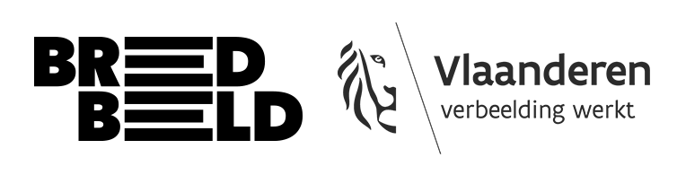

BREEDBEELD project funding media art:
draft version

This form provides an overview of all the information we need from you to submit an application. The questions are listed in the same order as on the online form, as is the number of words you need to take into account. Use this document to prepare your online application.

- General information

- First name & surname:
- Email address:
- Year of birth:
- Phone number:
- Gender:
- Bank account number:
- Address (city & zip code):
- I declare that I am not entitled to any benefits under the “kunstwerkattest”:
- I declare that I am not (any longer) studying at an art academy²:
- Are you a member of a club or artists’ collective?
- Did you study at an art academy?

- Your project: content & practicalities

- What is the (working) title of your project?

- Subdiscipline of your project. (video art, photography, sound art, etc.)

- What is the amount you wish to apply for (in euros)? (You can apply for an amount ranging from a minimum of €500 to a maximum of €1.000.)

- What is your background and experience as an artist? (max. 200 words)

- Have you created work before? List only the most relevant works for this application. Provide links and passwords if applicable. List them as bullet points and give up to 3 references. (max. 75 words)

- Describe your project. Explain how you intend to approach it in terms of content and form. What is the subject, the concept? Which techniques and materials will you use? (max. 250 words)

- Where are you currently in your process? Have you done research on your subject? Have you tested things out already? (max. 100 words)

- Timing of your project. Provide a concise, bullet-point overview of the different phases of your project. When do you want to research, produce, complete (and possibly present)? Be honest and realistic. Do not over- or underestimate certain aspects. (max. 250 words)

- Who will you be working with or would you like to work with? Provide an overview of the people involved in realising your project. (max. 200 words)

- Are you collaborating with other (cultural) organisations? (max. 100 words)

- Developing your talent as an artist

- How do you see yourself growing and developing as an artist through this project? (max 200 words)

- Who could be the target audience for your project? Where would you like to show it? (max 100 words)

- Do you have other goals or ambitions with this project? What do you want to achieve with it? (max 100 woorden)

- Budget
Expenses

You cannot estimate all costs perfectly in advance, but try to draw up your budget as accurately as possible. Request quotes from specialised companies to estimate costs for equipment rental, technical support, transport, etc. as precisely as possible. Add these as an attachment or mention the source.

Explain why you are making a particular estimate: do you want to have prints made or are you looking for something second-hand? How much time do you need in a FabLab, and what budget is required for this?

Please also read the regulations carefully to find out which costs you can enter but which are NOT covered by this funding.

- Explanation of your budget. Here you can explain why you have made certain choices, insofar as you cannot include them in your budget table. (max 250 words)

- Have you applied for support elsewhere? Provide a bullet-point overview of ongoing applications. If you are planning to submit an application somewhere, you may also add this. Be as open and transparent as possible. (max 100 woorden)

- Attach your budget as an Excel file. Max. 25MB.

- Attachments

- Briefly and clearly summarise which attachments you are adding to your file. You may add a maximum of 5 attachments. These can be sketches, mood boards, portfolio, etc. If you are adding quotations, please combine them into a single document.

- Upload your attachments here. Max 100MB in total.

A “kunstwerkattest” is not the same as registration for an amateur arts allowance (AKV). People with a “kunstwerkattest” entitling them to benefits are not eligible for this project funding. ² People (still) studying at an art academy are not eligible for this project funding.

