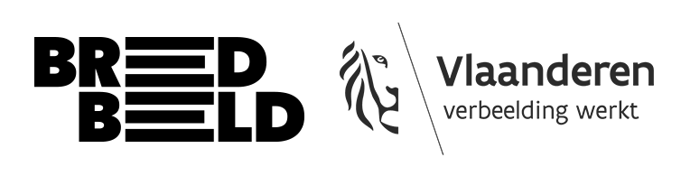

Div.fuse
draft version

This form provides an overview of all the information we need from you in order to submit your project. The questions are listed in the same order as on the online form, as is the number of words you need to take into account. Use this document to prepare your online application.

Submit everything before 25 March 2026. Be sure to read the rules and conditions carefully to see if your project is eligible.

- General information

- First name & surname:
- Email address:
- Date of birth:
- Phone number:
- Gender:
- What is your Instagram handle?
- Address:
- Did you study at an art academy?
- Are you a member of a club or artists’ collective?
- I declare that I am not entitled to any benefits under the “kunstwerkattest”

- Your project: content & practicalities

- What is the title of your project?

- Did you create the work as part of a school project?

- What type of work are you submitting? (video art, photography, sound art, etc.)

- Artistic CV (max 200 words): Describe your background and experience. Add links (Vimeo, website, portfolio) to previous work, and don't forget the password.

- Describe your project here (max. 250 words): What is the subject, the concept? What techniques and materials did you use? Describe as specifically as possible how you want to exhibit your work. How do you envision the scenography? (If necessary, attach a document with images, sketches, etc. below.)

- Technical rider: Describe as accurately as possible what technical equipment you require (screen, projector, headphones) and what you will provide yourself. Compile a detailed list.

- Useful links to your work: List these in bullet points. Do not forget to include any passwords.

- Has your project been exhibited publicly before? If so, where?

- Any attachments to your project description: If necessary, attach a document with images, sketches, etc. The file may not exceed 15 MB.

IMPORTANT: Include your name in the file name: ‘surname_first name_portfolio’ for the files you upload.

A “kunstwerkattest” is not the same as registration for an amateur arts allowance (AKV). People with a “kunstwerkattest” entitling them to benefits are not eligible for this open call.

